**QUIZMASTER**

Created by BS-YTMLR.

QUIZMASTER has 3 parts. Home_page, Quiz_page,Result page.

HOME_PAGE

Created by Sebuhi Huseynli.

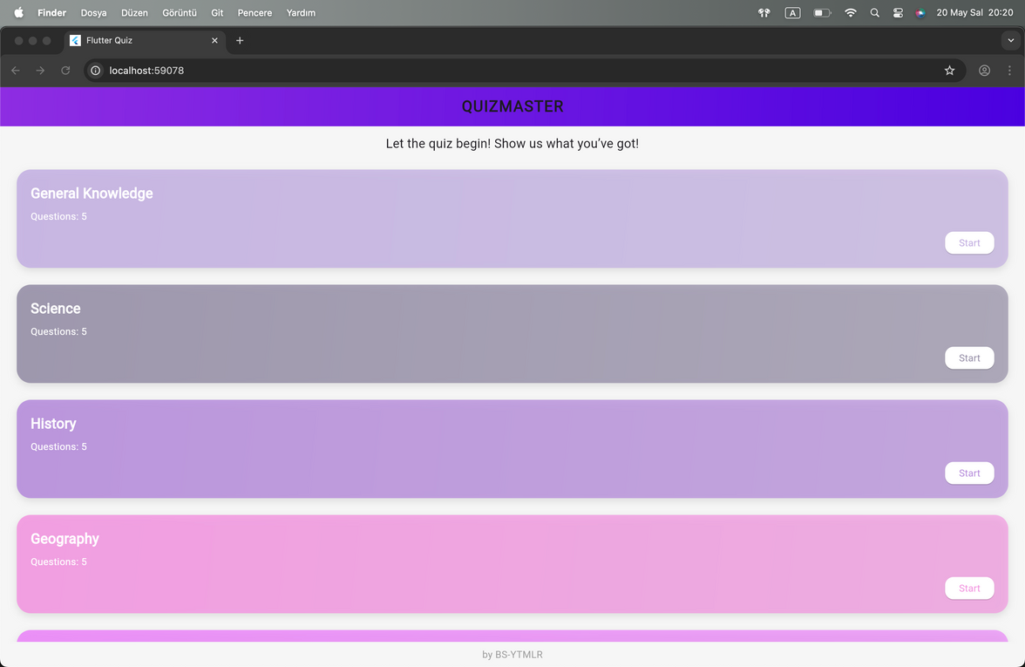

You can see the topic titles, number of questions and motivational sentences on this page.

The harmony of colors motivates participants.

If you click the “start” you can see;

QUIZ_PAGE

Created by Farid Hummetov.

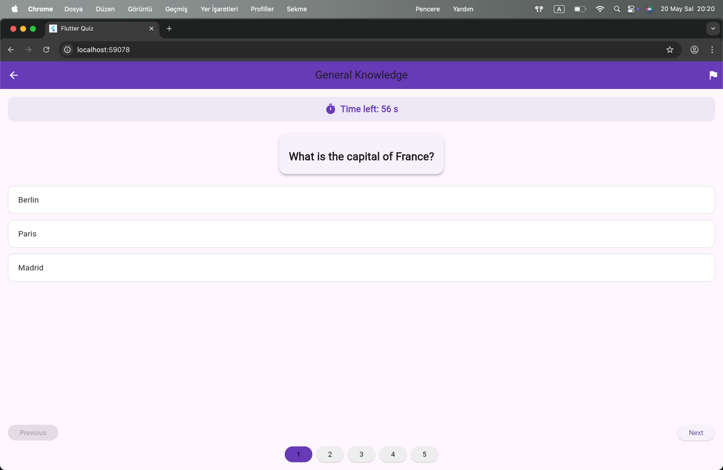

You can see the total remaining time and the transition to the next or previous question on this page.

You can jump to the desired question with the numbers you see in the middle bottom of the page.

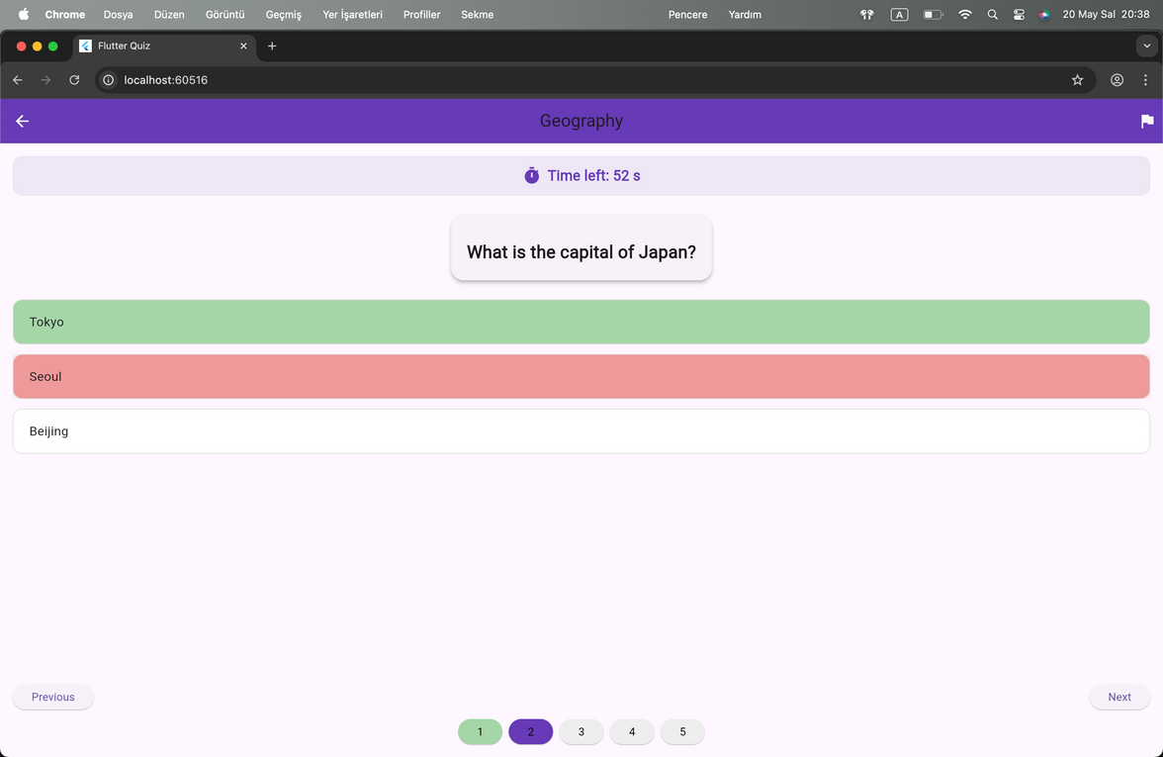

   
   
 



The correctness or incorrectness of the questions is displayed in green and red colors, respectively.

RESULT_PAGE

Created by Vusal Memmedli.

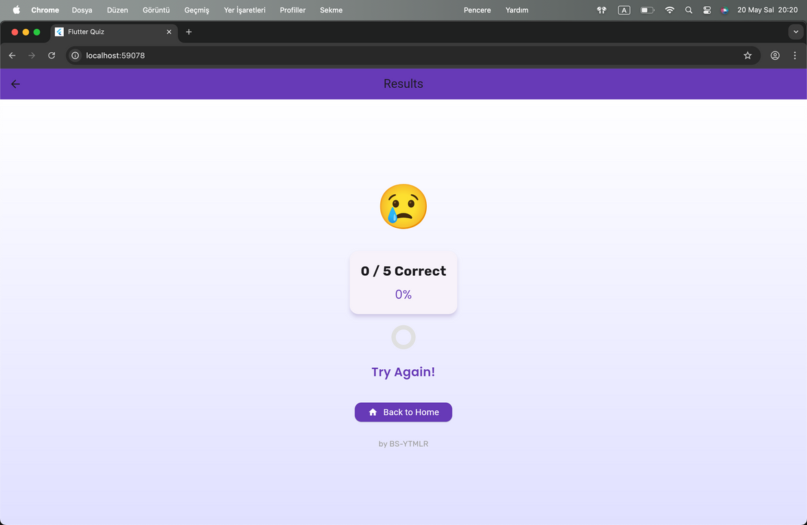

On this page you can see emoji and text according to the result;

percent >= 80

message = "Excellent!";

emoji = "🎉";

percent >= 50

message = "Good Job!";

emoji = "👍";

message = "Try Again!";

emoji = "😢";

You can also see a button to return to Home_page.

YOU CAN SEE ALL PAGE CODE İN [GitHub - vsll44/flutter-quiz-app](https://github.com/vsll44/flutter-quiz-app)